WEEK-15-POINTERS

WEEK-15-POINTERS

REG NO:241801289

NAME:TAMILSELVAN.K

Q1

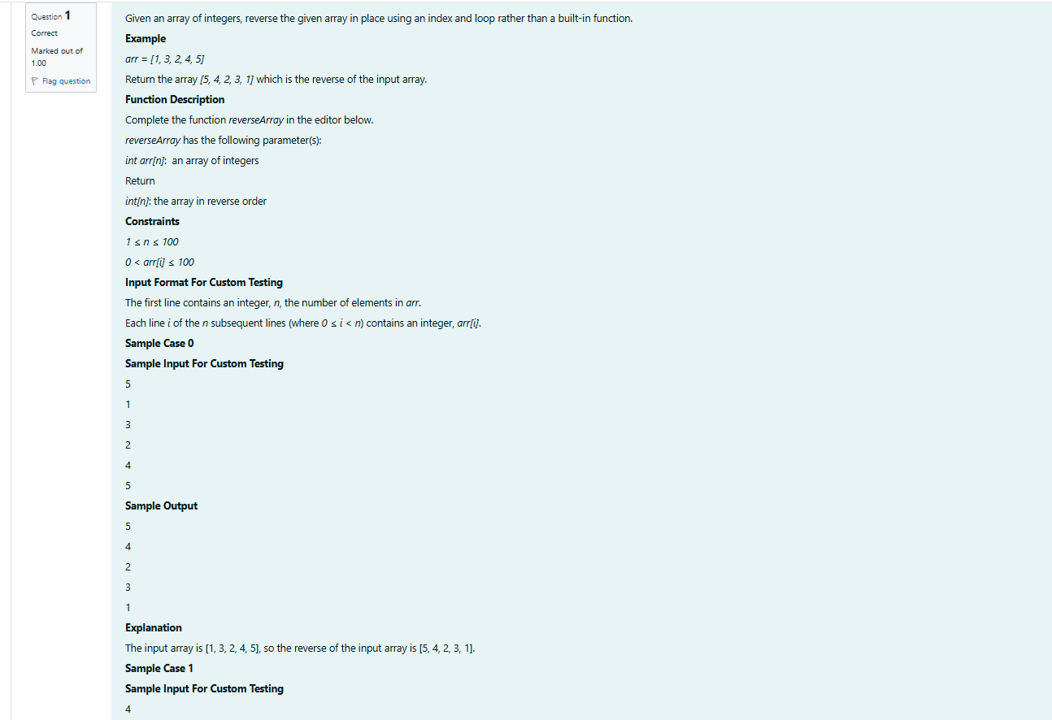

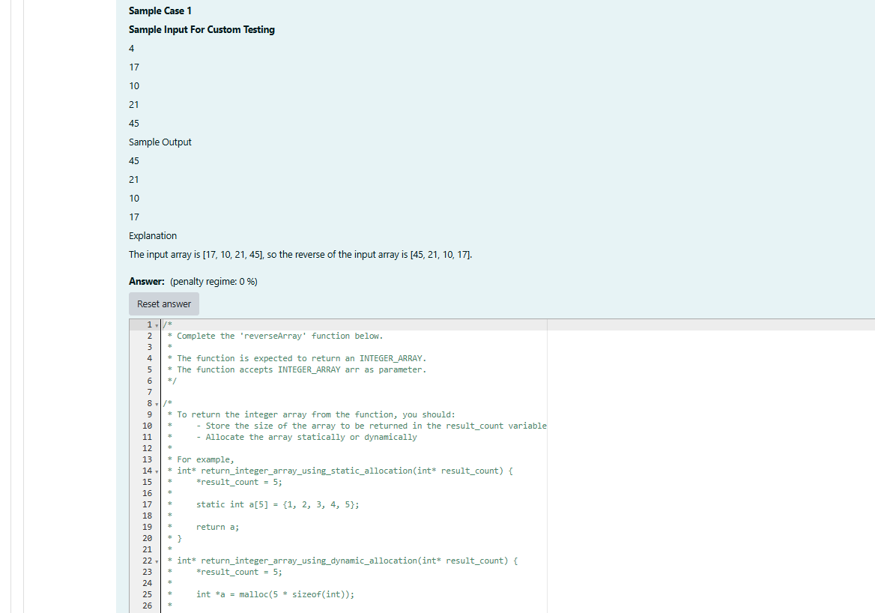

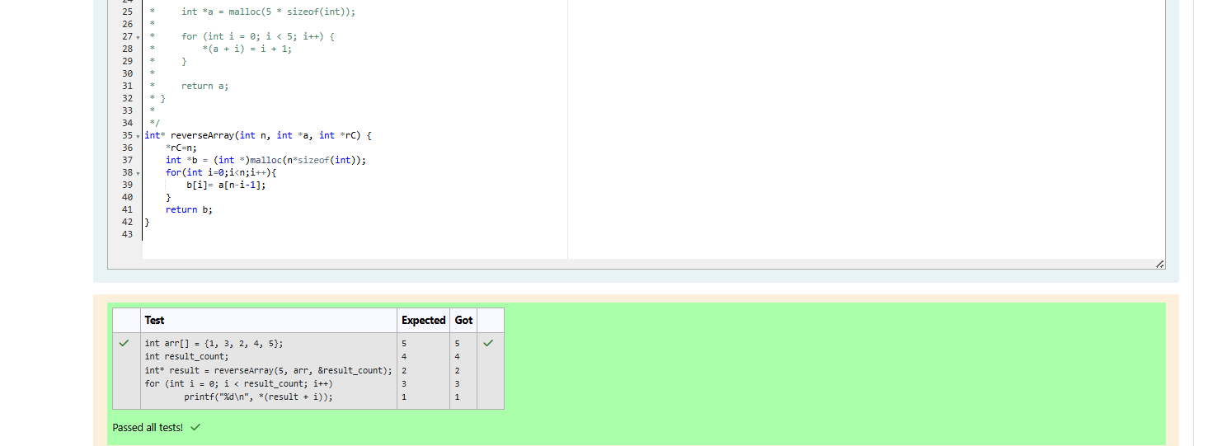

WEEK-15-POINTERS

REG NO:241801289

NAME:TAMILSELVAN.K

Q2

